FOR IMMEDIATE RELEASE
For more information, contact: Jessca Holcomb at info@shasc.org
Spartanburg Housing Authority
2271 South Pine Street, Spartanburg, SC 29302
www.SHASC.org

1/18/2017

Spartanburg Housing Authority Updates Text Notification System

Spartanburg Housing Authority will upgrade their text message alert and notification feature in January 2017. The upgraded text system will feature a short URL in the message body, instead of a full URL. The messages will continue to come from 96167 or 470-219-3777. Below is an example of a current alert with a full URL and a sample of the same alert when we introduce the short URL:

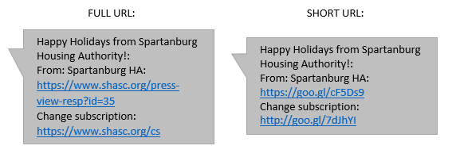

As shown above, the message body will have a Subject line (the article title, in the above example) and a From address of Spartanburg HA. There will still be an option to change subscription at the bottom of the message.

To sign up for updates from our website, to change your current subscription, or to unsubscribe from our website alerts, please go to our Sign Up for News & Announcements page: https://www.shasc.org/signup.

We will be glad to hear any feedback from our subscribers on this text notification upgrade. To provide feedback, please let us know through our Contact Us form (https://www.shasc.org/contact_us) or send an email directly to Jessica Holcomb at info@shasc.org.

Thank you!

Jessica Holcomb,
Deputy Director

